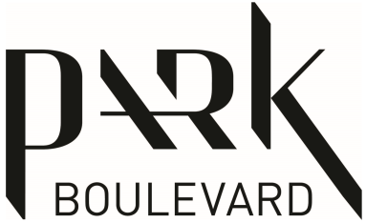 | APPLIANCE MANUALS

Strata Lot #: | Suite #:
Suite Type:

- Fridge
- Cook Top
- Oven
- Microwave
- Hood Fan
- Dishwasher
- Washer
- Dryer
- Smart Thermostat
- Smoke/Carbon Monoxide Alarm
- Alarm System (Townhome#_____/ Penthouse# _____)
- Other ______________________________

